International research seminar on: “Managing Natural Resources in Statuses of Autonomy”
(Geneva, 4 June 2012)

Natural Resources in Greenland:
An Inspiring Experience for the Sahara Region
Lise Lyck
Introduction

This article includes as Part One factual information on Greenland and the structure of the Greenlandic economy, and factual information on the Sahara Region, south of Morocco. It is needed in order to have a basic understanding of what Greenland and the Sahara Region are, seen from an economic, political and geographical point of view. Furthermore, the current economic situation in both Greenland and the Sahara region is presented together with the development of the last years.
Part Two of the article deals with the constitutional framework conditions for Greenland in relation to being part of the Danish Realm, Greenland being situated in the Arctic with a geostrategic position for more Southern powers (America, the Nordic countries and Russia), being inhabited by indigenous people and having a prominent position in relation to sustainability. It also deals with “the Moroccan Initiative for Negotiating an Autonomy Statute for the Sahara Region”, as presented by Morocco to the Security Council on 11 April 2007.
Part Three deals with natural resources both in Greenland and the Sahara Region. Firstly a short introduction to living resources, mainly the fisheries is presented. Secondly, the mineral resources are presented and analysed in depth. It includes the search for minerals, petroleum and gas before and after 1979. Furthermore, it includes the development and content of the mineral laws. In this context, the Greenland strategy for mining is presented. Finally, the status on minerals and petroleum resources in Greenland and the Sahara region is presented.
Part Four includes the conclusion and the perspectives for ownership and management resources that can be learnt from the Greenland experiences, in particular in the context of the Moroccan Initiative for the Autonomy of the Sahara Region.
The development of both Greenland and the Sahara region is a story about:
- Having an hinterland position in relation to global development;
- An indigenous people or a local population achieving more political influence;
- How conflicts and discussions on ownership between a state and an autonomy (Home Rule / Moroccan Initiative) can be achieved peacefully through negotiations;
- How the international community and international organisations (mainly the UN) can facilitate a process for achieving solutions;
- How a gradual development process can be successful and in a dynamic way lead to economic development;
- How learning about Greenlandic experiences can serve as inspiration worldwide to solving conflicts on natural resources between states and autonomies as in the case of the Sahara autonomy Plan proposed by Morocco.

Part One: Main Facts on Greenland and the Sahara Region and the Structure and Development of Their Economy

1.1 Facts about Greenland and the Sahara Region and Structure of their Economy

To understand the analysis in the sections below, it is necessary to have some basic information on Greenland and the Sahara region as well as their economic structure. It is especially important to be aware that while Greenland is the largest island in the world with a territory of 2,166,086 km², the Sahara is one of the potentially largest territorial regions of Morocco. Here, it is needed to notice that a large part of Greenland is covered by the icecap while the Sahara region is mainly a desert and coastal area, at the border of Algeria in the East and Mauritania in the South. It implies that the size of the Greenland territory free of ice is eight times the size of the territory of Denmark and the same size as the Swedish territory, i.e. it is still a very large area for a population of only 56,749 people. Furthermore, the people living in Greenland are living in four big municipalities (see figure 1.1. The number of municipalities was reduced from 18 to 4 in 2009), while the local population of the Sahara is living in the main cities of Laayoune, Dakhla, Boujdour and Smara and shares the same historical, social et cultural traditions and heritage as the local populations in the South of Morocco.

It is also important to be aware of climate differences from the South of Greenland to the North of Greenland, i.e. from climate conditions found in many Northern societies to the extreme climate conditions in the Northern part of Greenland. On the opposite, the climate in the Sahara region is mainly the same of the one in the coastal cities in the South of Morocco. Another thing to notice is that Greenland has had a pure hinterland position and has had and to a certain degree still has a function as a treasure chest for the rest of the world. Furthermore, the development in technology over time has created a lot of new possibilities for living in Greenland and making use of the Greenland resources. The Sahara region, long known for its pastoralism and nomadism, has scarce natural resources. However, since its reintegration to the Kingdom of Morocco, in 1976, after 90 years under Spanish colonialism, the Sahara region has experienced unprecedented development opportunities and strong national solidarity to upgrade the economy of the region and promote its resources to the benefit of the local population.

Table 1.1: Facts about Greenland 2012
Size of population (2012) | 56,749⁽¹⁾
Size of population in Nuuk (the capital) |  | 16,181
Size of population aged 18-66 |  | 38,469
Employment (2010) | 28,386
Unemployment (2010) | 2,412
Gross Domestic Product (billion DKK, 2010) | 12.3
Per capita (1,000 DKK) | 217.5⁽²⁾
Disposable Gross Domestic Income (billion DKK 2010) | 16.1
Per capita Gross Domestic Income (1,000 DKK) | 285.2⁽³⁾
Area (km²) | 2,166,086⁽⁴⁾
Density of population (/km²) | 0.027/km²
Official language | Greenlandic
Currency | DKK
Constitutional setup | Part of the Danish Realm with Home Rule⁽⁵⁾
Source: Christensen and Jensen (2012); Lyck (2012)

Annotation: Exchange rate information: referring to the exchange rates of 24 April 2012, 1 euro equals 7.43DKK and 1 USD equals 5.66 DKK (Danish Central Bank, 2012).

The size of the population in Denmark is 5,580,516, i.e. approximately one per thousand of the size of the population in Denmark.
- 88 % Inuit including Inuit Danish mixed and 12 % Europeans, mostly Danes.
- Compared to 314.4 in 1,000 DKK in Denmark.
- Compared to 317.1 in 1,000 DKK in Denmark.
- Water % 83,1
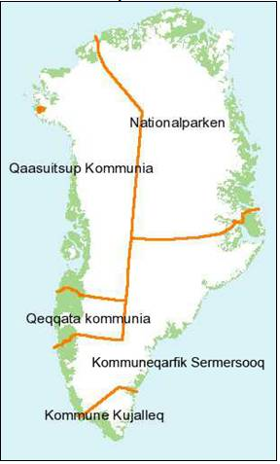
- Home Rule since 1979, and with the Home Rule Act revised in 2009

Figure 1.1.The four municipalities in Greenland

Source: Statistics Greenland, 2012

1.2 The Current Economic Development in Greenland and the Sahara Region
As seen in table 1.2 the international financial and economic crisis that hit the global economy in 2008 had only a small impact on the economy in Greenland. The reason to this was not as found in the underdeveloped or less developed countries in Asia, Africa and South America where countries have increased their mutual trade and thereby decreased the dependency of Europe and the US. The reasons for the development in the economy in Greenland are the following:
- Denmark pays an annual block grant to Greenland of approximately 3.5 million DKK (2010: 3,495 million DKK)
- Income from partnership and fisheries with the European Union, annually approximately 200 million DKK (2010: 221 million DKK)
- Income from the (high quality) fisheries in the form of shrimps, halibut and cod
- Income from mineral activities

Although the Greenland economy is not diversified, the four items listed above make the Greenland economy robust and create a solid platform for other income creation. We could say the same thing regarding the economy of the Sahara region, which continues, since 1976, to register steady trends of economic growth, thanks to its diverse structure, the performance of private and public enterprises and the volume of economic investment in the region.

Interesting to notice also is that the fisheries count for approximately 90 percent of the Greenland exports, mainly based on an annual catch of fishing in the Greenland waters about 90,000 tonnes. Similarly, fisheries are a key sector in the local economy of the Sahara region, particularly in terms of volume of production and jobs creation. The annual catch of fish in the Sahara waters is about 1 million tonnes.

Interesting is also to look at the mining activities. Especially exploration activities in minerals and petroleum have gone up, but until now the activities have not so much continued up to exploitation. Furthermore, mining includes a development where some activities end and others have a new start, for example the olivine mining at Manitsoq has been closed down, while the goldmine in the South of Greenland (Nanortalik) was reopened in 2011 with jobs for 80 employees. Mining resources and activities are also important in the Sahara region. The main activity therein is linked to the extraction of phosphates. Prospecting for petroleum in the Sahara region has been unproductive up to now.

Worth to notice is also that the educational level has been increased year by year (not shown in table 1.2). Similarly, educational growth in the Sahara region expanded in the last 20 years and is competing with rates registered in the northern Moroccan cities like Casablanca and Rabat.

Mentioning all those positive elements is, however, not the same as stating that the Greenland economy is without problems. The export of goods and services has been stagnating and has had problems in 2010 and 2011 (not seen in table 1.2). There was a deficit on the Greenland trade balance of 2.4 billion DKK corresponding to approximately 20 percent of gross domestic product, and it was the biggest deficit ever registered. The balance of payment is of course different from the trade balance due to the services from the sources mentioned above. The main problem for the economy in Greenland is still that the economy is not diversified and that more mining activities need to go into the exploitation phase.

Table 1.2: Supply balance, real growth rates, Greenland national account 2004-2010 (percent)
 | Fraction of BNP 2010 | 2004 | 2005 | 2006 | 2007 | 2008 | 2009 | 2010
Private consumption | (51.1) | 6.3 | 5.2 | 3.1 | -1.1 | -1.1 | 0.3 | 4.4
Public consumption | (53.8) | -0.1 | 0.5 | 6.6 | 1.0 | 6.7 | -2.7 | -0-3
Gross Investment, total | (55.1) | -7.2 | 41.7 | 2.1 | 35.0 | 45.1 | -4.2 | 33.3
Immaterial fixed assets⁽¹⁾ | (27.0) | -8.5 | 37.9 | 3,1 | 24.0 | 36.3 | 0.8 | -17.7
Export of goods and services | (27.9) | 12.7 | 2.9 | -3.5 | -1.4 | 10.6 | -12.9 | 6.5
Total Domestic Product | (188.0) | 3.8 | 7.1 | 2.6 | 4.7 | 12.3 | -4.2 | 10.2
Import of goods and services | (88.0) | 3.0 | 12.6 | -3.5 | 8.7 | 26.8 | -10.6 | 23.3
Gross Domestic Product | (100.0) | 4.3 | 3.7 | 6.6 | 2.4 | 3.0 | 0.8 | 1.2
Source: Christensen, A.M. and Jensen, C.M. (2012) and Statistics Greenland
- Investment in immaterial fixed assets are primarily income from mineral exploration, in relation to both minerals and petroleum

Part Two: Framework Conditions

The Constitutional Relations between the Autonomous Regions and the Central State

- Greenland and Denmark
The relation of Greenland to Denmark has a long story. It goes back to the Vikings who around year 1000 settled down in Greenland on the West coast, where ruins from that time still are visible and now part of the cultural tourist attractions. The communication between Greenland and Denmark ceased during the Middle Age and in the 1600s the Danish king sent out expeditions to find out about the situation and nobody with a Viking background was found. It led to a decision by the Danish king that the priest Hans Egede should go to Greenland to christen the Inuits living there and also look for mineral resources. Greenland became in 1815 a Danish colony and had this position until the Danish Constitution of 1953, which gave Greenland a position as a Danish county.
In 1979, Greenland obtained Home Rule status (Lyck, 1996: 122-162; Act no 577 of 29 November 1978). Greenland became a distinct society within the kingdom of Denmark. The most difficult part to agree on for the Danish state and the Greenland politicians was the ownership to the subsoil rights (see Lyck 1996 and Part Three in this article). For the transfer of areas from the Danish state to the Greenland authorities, see Annex 1. It illustrates the planned gradual approach. In connection to the political process with establishing the Home Rule in Greenland three political parties were formed: Siumut, a political party established in 1977, on a Social democratic political basis; Atassut, a liberal political party established in 1978 and in favour of a close connection to Denmark; and Inuit Ataqatigiit (IA), a left-wing political party with the goal of the Inuits having the rights to the land and also being part of the international society (Greenland Statistics Politics, 2012).
In 2009, a new Home Rule Act replaced the old one (Lov nr. 473 af 12/06/2009, Selvstyreloven). It included a solution to the question on mineral resources and became the foundation of the new act on mineral resources in Greenland (Act no 7 of 7 December 2009). The Act recognizes that the people of Greenland are a people pursuant to international law with the right of self-determination. The Act is based on a wish to foster equality and mutual respect in the partnership between Denmark and Greenland.
Chapter 3 of the Act is about the economic relations between the Greenland self-government authorities and the Danish government. Article 5 provides that the Danish Government shall grant the Greenland self-government authorities an annual subsidy of 3,439.6 million DKK in 2009-price level and that it shall be adjusted in accordance with the increase in the general price and wage index. One twelvth shall be paid each month.
The articles 7, 8 and 9 in the Act deal with the revenue from mineral resources. Revenue from mineral resources shall accrue to the Greenland self-government authorities. It goes for license fees for prospecting, exploration and exploitation as well as for taxation in relation to the mentioned items. If revenues from mining increase more than 75 million DKK, the block grant shall be reduced by half the revenue that exceeds 75 million DKK. If the government subsidy is reduced to zero DDK, negotiations shall be started between the government and the Home Rule authorities regarding the future economic relations between Denmark and Greenland.
The Act clearly states that the government of Greenland can take over the area of mineral resources, and that it is the legislative and executive authority within the area of mineral resources. As a consequence the till-then Joint Committee with members from Denmark and Greenland was abolished.
The Act also gives Greenland comprehensive powers on foreign affairs. The Act states that Greenlandic is the official language. Article 21 deals with Greenland’s access to independence. It is stated that decision on Greenland’s independence shall be taken by the people of Greenland also if the Greenland people wants sovereignty. Annex 4 shows the non-taken over responsibilities.
The Danish Realm consists since 1979 of Denmark and the two Home Rule jurisdictions, the Faroe Islands (Home Rule since 1946) and Greenland. Both the Faroe Islands and Greenland have each two members in the Danish Parliament as stated in the Danish Constitution of 1953. The relations between Denmark and Greenland have been based on a development policy for Greenland, that started after World War II and was further developed in the 1950s (the G50 plan) and in the 1960s (the G60 plan). The G60 plan included the development of the Greenland fisheries.
Worth to notice is that, although Denmark is a member of the European Union (EU), the Faroe Islands has never been member of the EU. Greenland became a member of the EU in 1973 together with Denmark, but Greenland was promised a referendum on membership when Home Rule was achieved. The referendum ended in a ‘no’ to EU membership, and Greenland left the EU as the one and only jurisdiction until now in 1985. Although Greenland is not a member of the EU, Greenland has had fisheries agreements with the EU since 1987.
It is characteristic for the constitutional relationship between Denmark and Greenland that the changes in the relations have been achieved peacefully based on negotiations.

B- The Sahara Region and Morocco
The history of the Sahara region is considered in Morocco as part and parcel of the history of the Kingdom. In comparison with other African countries, Morocco constitutes a unique case in the history of colonization as well as in the decolonization process. Due to its geographic position, Morocco has always entertained strong relations with its European neighbours, mainly Spain, Portugal, France and Italy. Since the 15th century, Spain and other European countries became interested in the Moroccan northern and southern coasts which possess large fishery potentials. And in 1884 an expansionist movement was launched towards the southern coast of Morocco and Spain succeeded thus in imposing its protectorate on the Saharan coast from cape Blanc to cape Bojador. It was in 1912 that the Moroccan territory was effectively split up into several zones of occupation, each controlled by either two powers (North and South by Spain and the centre by France) and the city of Tangiers - in the Northwest of the country - was an international zone.
This colonial peculiarity led Morocco to gradually negotiate the recovery of its sovereignty separately with France and Spain. In 1956, Morocco regained the areas under French occupation and the Northern provinces occupied by Spain (Tangiers was reintegrated into Moroccan sovereignty in 1957). Then Morocco negotiated with Spain the retrocession of the territories in the South. Thus, Morocco regained Tarfaya in 1958 and Sidi Ifni in 1969. As for the remaining Saharan territories, Saquia Al Hamra and Rio de Oro, Spain withdrew from them in 1975 following the Madrid Agreement.
As a matter of fact, decolonisation in Morocco was long and difficult; however, this process has always been peaceful and followed the path of dialogue and negotiations with Spain, a friendly neighbouring country. Since the return of the Sahara to Morocco in 1976, the Saharan provinces always participated in Moroccan general elections to elect their representatives in the local Councils and the National Parliament. Moreover, the King established in 2009 the Royal Advisory Council for Saharan Affairs, which was asked to assist the King in the issues relating to the defence of the Kingdom’s territorial integrity and national unity, the promotion of social and economic development of the southern provinces and the preservation of their cultural identity.

The Strategic Geographical and Political Position of Greenland
The geographical position of Greenland and the fact that only few people lived in Greenland (back in the period 5000-2000 BC), combined with the severe climate conditions and the difficult accessibility possibilities have had a decisive role for the political position of Greenland. In many ways, the position had parallels to the rest of Circumpolar World.
For many years, the Circumpolar World was totally controlled by the sovereign more Southern states. The role played by Greenland was mainly the hinterland role as a treasure chest. Since the end of the 1800s and especially in the 1900s, the Circumpolar World has got a military strategic role for the Southern states that have Circumpolar areas within their territory.
During the Second World War and the Cold War period, it resulted in three different developments of the Circumpolar World. Alaska and the North of Canada were controlled by the US and the Canadian interests. The Asian part of the Circumpolar World was controlled by Russia (the former Soviet Union). The remaining parts of the Circumpolar World – Greenland and the Faroe Islands as well as the Northern areas of Norway, Finland and Sweden – were controlled and developed in line with the development Nordic welfare state development.
First, in the end of the 1980s after Mikhail Gorbachev’s speech in Murmansk in 1986 (Gorbachev Speech, 1987), the Circumpolar World got the possibility to meet and exchange experiences and thoughts about a development based on people living in the Circumpolar World. In Alaska and Canada, land claims have resulted in more influence and rights for indigenous people, resulting in better economic development and in more influence on achieving subsoil rights. These activities have been of major importance for the claims to more rights for people living in Alaska and Canada in relation to the subsoil as well as their constitutional setting.
In the North of Siberia the 26 small indigenous people living there have also achieved more influence on their own development, and so has the Republic of Sakha (Yakutia) after the Constitution of the Russian Federation came into force in 1993. The Nordic part of the Arctic areas has achieved Home Rule (Denmark) and special agreements for the Sami people. The agreements are different for the Sami people living in Northern Sweden, Northern Norway and Northern Finland. The Sami peoples living in Norway, among the Sami people living in the Nordic countries, have achieved most influence on their own areas.
Although freedom in the Circumpolar World has increased and the Arctic Council including the eight Arctic states (Canada, USA, Russia, Iceland, Denmark, Norway, Sweden, Finland) and six organisations for indigenous peoples living in the Circumpolar World has been established in 1996, there are still strategic and military interests in the Arctic that influence the economic development in the Circumpolar jurisdictions.

Indigenous People of Greenland
Most of the persons living in Greenland are indigenous people. It means that they are Inuits and mixed with Danes who have had their life in Greenland. The Inuits count for 88 percent of the total Greenland population (56,749 people). The remaining 12 percent are Europeans, mainly from Denmark.
Table 3 shows the historical development of peoples who have inhabited Greenland.
The recognition of being an indigenous people gives rights to decision-making on its own interests. The basis for these rights was originally found in the International Labour Organization (ILO) Convention 169 (ILO, 1989). Later the rights have been negotiated between NGOs and the United Nations. Over time, this development has resulted in still more comprehensive recognition of rights.
The latest United Nations Declaration on the Rights of Indigenous Peoples (107th plenary meeting 13 September 2007) includes 46 articles. Especially important is article 3: Indigenous peoples have the right to self-determination. By virtue of that right they freely determine their political status and freely pursue their economic, social and cultural development.

Table 3: Historical Settlement in Greenland
Period (approximately): | Name of settlement culture:
2500-2000BC | IndependenceI
2500-1000BC | Sarqaq
1000-700BC | IndependenceII
200-0BC | DorsetI
800-1000 | DorsetII
900- | Thule
982-1400  1721 | Vikings  HansEgede
1815-1953 | Danishcolony
1953-1979 | Danishcounty
1979-2009 | FirstHomeRuleAct
2009-  Source: Gad (1984); Lidegaard (1991); Lyck (2012) | SecondHomeRuleAct

Furthermore, article 4 of the UN Declaration includes rights to means for financing their autonomy functions, their cultural rights are stated in article 8. Article 20 and 21 outline the economic rights for indigenous people and are of outmost importance. It is also the case concerning article 26 with the rights to the lands, territory and resources. Furthermore, articles 27 and 28 as well as article 32 are of importance for indigenous peoples’ rights to their land, development or use of their land, territory and resources. Additionally, article 29 on sustainability is of great importance the mining production.
Unlike the people of Greenland, Sahrawis have never been considered as an indigenous people. They have always been considered as part of the Moroccan population and have always been historically, politically and culturally linked to Morocco. These bonds were disrupted only when the Spanish colonizer invaded Morocco and divided its national territory, breaking the homogeneity and unity of its population. To contribute to the current UN efforts to solve the dispute raised over the Moroccan character of the Sahara region, Morocco submitted in 2007, its “Initiative for Negotiating an Autonomous Statute for the Sahara Region”. This Initiative aims at allowing the population of the Sahara region to manage its own local affairs, including mining, through democratically elected regional Institutions, under the sovereignty of Morocco. The Moroccan Initiative would protect and promote the specificities of the Sahrawi local population in conformity with the international principles enshrined in the UN Charter

Sustainability
Sustainability has for a long time been an issue in the Nordic countries and already in 1969 a United Nations conference on the topic took place in Stockholm. In 1987, the UN report, written by the then Prime Minister of Norway Gro Harlem-Brundtland and entitled Our Common Future was published. Since then the topic of sustainability has been developed both in research, in agreements and in practice. For the Circumpolar World, especially the CO₂ emissions have created a high interest and especially in Greenland, because of the risks of the melting of the icecap. The development is already experienced in monitoring of the ice-covered area showing that it has withdrawn. For instance, in Ilulissat, it is easily seen that the ice has been reduced.
Furthermore, also pollution in relation to mineral activities has created a concern for damaging of the environment due to mineral activities (see the section on mineral activities below). Due to the importance of the sustainability issue it is therefore extremely important that the United Nations Declaration of Indigenous Peoples’ Rights (2007) includes the rights for protection of the environment and the productive capacity of land and resources. To conclude on sustainability, regulation on preserving the environment is having a high priority in laws and regulations of mineral activities in Greenland.

Part Three: Natural Resources (Living and Mineral Resources)

Living Resources
The catches of living resources in relation to Greenland have roots back to the hinterland position. It was seen in the period of whaling from 1400 to 1700, when whale oil was needed for the lamps in Europe. It was also seen in the hunting of marine animals for their teeth etc. used to make rare products for the king and the nobility.
The last 50 years, living resources have mainly been in relation to the fisheries. In Greenland, development of the fisheries began with in the G60 plan (Danish state plan for developing Greenland in the 1960s) based on which cities with factories were established. It meant that people moved from the settlements to the cities. Unfortunately, the temperature changed and reduced the possibilities for the catches of fish for a period in the 1970s but now fisheries are back as a decisive source of income creating in Greenland. The fisheries are the main industry in Greenland today. They are based on biological advice to ensure sustainability of the living resources. Tables 4, 5, and 6 show the level of the main catches of living resources in Greenland, and table 7 shows the fleet of fishing vessels in Greenland.
International agreements on fisheries play an important role in the fisheries. Since 1985, there have been agreements between the EU and Greenland. The agreements have given duty-free access to the European market and payment for EU fishery rights in Greenland waters. The amount paid was annually 80 million DKK. The agreement was revised in 2003. It includes Greenland giving quotas to the EU and receiving a payment about 320 million DKK of which approximately 240 million DKK is a payment for fisheries rights transferred to the EU.
Besides the EU agreements, there are also some minor agreements with Russia, Norway, Iceland and the Faroe Islands. The agreement with Norway goes back to 1991. The agreement between Russia was signed in 1992. Since 1997, there has also been an agreement with the Faroe Islands on mutual access to their fisheries within the 300-nautical mile zones. In 1998, an agreement with Iceland was achieved. Besides the mentioned agreements, there have also been consultations between Greenland and Canada (Nanoq, 2012). For more detailed information on the fisheries partnership agreement, see Annex 2.
Most fisheries in Greenland are based on licences, on Total Allowable Catch (TAC), and on political decisions. By the end of 2011 the fishing fleet included approximately 525 vessels. They are mainly owned by private persons. However, some of the big trawlers are also owned by Royal Greenland AS, a state-owned corporation. The financing is mainly by foreign banks etc.

Table 4. Total Fishing in Greenlandic Waters by Greenlandic Vessels
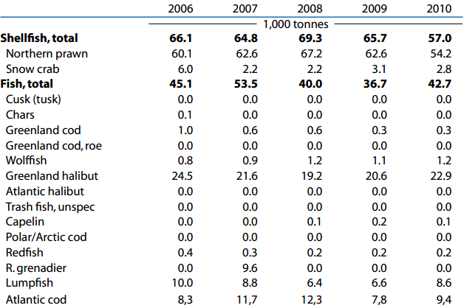
Source: Greenland Statistics, 2012

Table 5: Seal Hunting
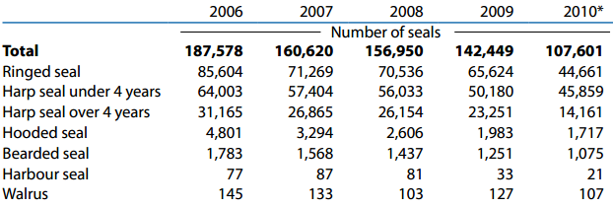
*Provisional Figures
Source: Greenland Statistics, 2012.

Table 6. Whaling
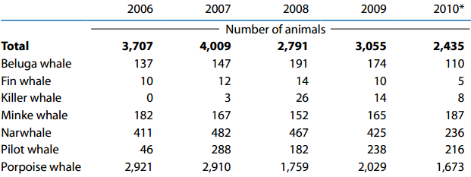
*Provisional Figures
Source: Greenland Statistics, 2012.

Table 7. Fishing vessels
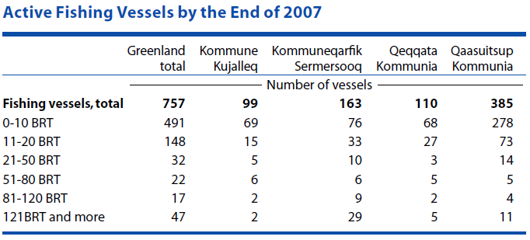
Source: Greenland Statistics, 2012 (figures not updated)

In Morocco, the Sahara region is characterized by the diversity of halieutic species whose composition and abundance are conditioned mainly by hydro-climatic factors reigning in the African West coast. The exploitation of this biodiversity led to the development of public and private investment in the Sahara region in the maritime field. These investments have allowed:
- The constitution of a fishing fleet composed of 190 ships in addition to 5,866 boats for craft fishing;
- The development of dynamic and effective octopus craft fisheries ensuring the provisioning of a local completely upgraded freezing industry;
- The initiation of small pelagic fisheries which will start with the setting up of a specific development plan being adopted;
- The installation of an industrial development potential relating to fishing products amounting to about 130 units, i.e. 30 percent of the total staff at the national level;
- The construction of two training institutions in Dakhla and Laâyoune;
- The equipment of fishing ports with means of rescuing human lives at sea and with medical units;
- The construction of unloading points arranged for the training of craft-fishing sailors and the improvement of their living and working conditions.

Mineral Resources
Mineral resources in Greenland have for many years been a main issue in relation to the hinterland position. As mentioned, when Hans Egede went to Greenland in 1721 on behalf of the Danish king he was tasked to look into the possibility of finding minerals that could be exploited. In 1741, he reported that there was a possibility to exploit graphite. Foreigners were also active in the first mining events in Greenland. The Germans began a coal production in the Disco Bay area, which continued and was taken over by the Danish state, but stopped in 1973, just as the first oil crisis began. Copper mining was carried out by an English corporation from 1851-1852.
Many mining activities have taken place, all related to Greenland being a treasure chest for minerals. For instance, iron, manganese, diamonds, gold, silver, uranium, etc. have been among the minerals investigated and mined. Mining is normally assumed to have the following impacts:
- Higher Gross Domestic Product
- Higher share of government revenue in GDP
- Higher wages than the average wage level in the traditional economy
- Reduced incentives to invest in the non-mining activities
- A higher share of income relative to GDP for foreign production factors
- More unequal income distribution
- More migration from rural to urban areas
These impacts have not been dominant in Greenland, maybe due to the operational running of the mining activities and the relative low volume of activities. Among the mining activities before 1979, only three activities shall be shortly presented here: the cryolite mining, the mining in the Black Angel and the exploration for petroleum.
- Cryolite was called white gold. The mining took place in open mining at the place called Ivittuut. It was large-scale mining and took place especially after cryolite was found to be crucial for the production of aluminium. The production was undertaken firstly by a Danish private corporation and from 1940 by a Danish limited corporation called the Danish Cryolite Company that among the shareholders included the Danish state. It was not the Danish state that got the main part of the profit, but the private company. The production ended in 1962, but shipping of cryolite from Greenland continued until 1987, when all activities ended after 130 years of mining. More than 4 million tonnes were produced. After the end of production, cryolite in the aluminium production was replaced by synthetic cryolite. Cryolite gave the few people living in Iviituut the highest average incomes in Greenland and incomes higher than the incomes in Denmark (based on Krak, 1950 and Topp, N. 1990).
- The Black Angel was a lead-zinc and silver mine situated in Maarmorilik close to Ummannaq, 400 km north of the Arctic Circle in East Greenland. The name ‘The Black Angel’ referred to an angel-like outcrop of dark politic schist in an otherwise light coloured cliff-face opposite the small settlement of Maarmorilik in the then-municipality of Ummannaq. The deposit was found in the 1930s.The Black Angel was operated by from 1973-1986 by Cominco Ltd. with Greenex A/S as the operating corporation, and from 1986-1990 by the Swedish company Boliden AB. The silver paid for the transport to the markets, but the main mining was lead and zinc. It is estimated that there still is a reserve of 2 million tonnes left that could be mined. It was in all years a very profitable mining. In total 13.6 million tonnes with an average grade of 12.3 percent Zn and 4 percent Pb were extracted. The Mineral Resources Administration for Greenland calculated in 1991 the income in Greenland from the mining to 788,223 million DKK. The annual employment in Greenland was around 300 of which approximately 10 percent were Greenlanders (Greenex A/S: annual reports). It also brought mining into the Greenland society as a socio-economic phenomenon as it gave rise to the first strike in the labour market in Greenland. Investigations made by DMU (Danish Environmental Investigations and part of the Danish Ministry for Environment) 20 years after the stop of the mining showed that the water was still heavily polluted by the mining activities. It has been a main reason for the Greenland authorities to give high priority to environment (see the section on sustainability above).
- Petroleum: The search for petroleum began after the first oil crisis in 1973. Five drillings off shore close to Sisimiut in West Greenland were initiated. However, the test drillings were not successful and furthermore the prices of petroleum decreased in the 1980s. Another reason for giving up the activities was the lack of knowledge, as it was not found realistic that commercial findings of hydrocarbons could take place. This remained the perception until the late 1980s, when new knowledge found that the continental platforms had sediments that could offer an opportunity for finding petroleum or gas. Based on this, new activities took place in the 1990s, as mentioned in the following section.
In the Sahara region, the main local mineral is phosphates. According to a study conducted in 2010 by the International Fertilizer Development Center (IFDC), the reserves of the Sahara region are estimated to 1 billion m³, which is about 825 million tonnes (out of 51 billion tonnes in Morocco as a whole) or 1.6 percent of the total reserves of phosphates in Morocco. In 2010, the sales amount of Phosboucraâ (USD300 million) represents 6.5 percent of the sales amount of Moroccan Office of Phosphates (OCP), which is USD4.6 billion. All this income is reinvested into maintaining the exploitation of the Boucraa Mine and in the Sahara region. Hence the contribution of the Sahara region to the general activity of the OCP was economically negative during the last 27 years (1976-2008), with an accumulated deficit of USD560 million by PhosBoucraa, entirely sustained by the OCP. The phosphates sector is the first private employer in the Sahara region, with 2,168 employees, 55 percent of whom originated from the Sahara in 2011, against 39 percent in 1975, at the departure of the Spanish occupying power. Moreover, from 2001 to 2011, 1,043 employees were recruited out of whom 810 originated from the Sahara, which is 78 percent of the total recruitment.
The mining sector, and particularly the phosphates sector, impacted positively the region and its local population in terms of local capacity building: the first training centre was open in Laayoune in 1995, and medical and social infrastructure was developed to benefit the employees and their families.

Search for Minerals, Petroleum, and Gas after 1979 (Home Rule) in Greenland
When looking at development of mineral resources as a main source for the economy, there are some significant parameters to be aware of:
- The geological potential for minerals
- Mineral legislation
- Fiscal conditions
- Institutional factors and framework conditions
- Political stability

- There seems to be a huge potential for mineral exploration and exploitation in Greenland, and it goes for petroleum too. In relation to this, it is worth to mention that scientific research has been carried out in Greenland already from the 1870s. It began with the establishment of the Commission for Scientific in Greenland by a Danish professor in geology in 1878 and continued as a state commission with scientists as members. It means that, seen in a world perspective, there exists a unique collection of scientific data on Greenland including geology, flora and fauna as well as – but from a later period – data on the society. The data is mainly in Danish, which explains why it has only been utilized on a small scale. As a consequence, Greenland is not only a treasure chest in resources but also in scientific data.
- Mineral legislation is dealt with in the next section.
- Fiscal conditions: attraction of capital from Denmark and other countries, mainly in the form of capital from multinational companies engaged in mining and petroleum activities, is needed to have the required investments financed.
- Institutional factors and administrative framework conditions have been established during the last 15 years and are now in place for mining activities.
- Political stability in Greenland has been extremely high compared to other autonomies and states. There have only been five Premiers in the Greenland Home Rule period from 1979 to 2012. The first three Premiers came from the Siumut political party and the last two from the political party Inuit Ataqatigiit (IA). The Premiers for Greenland have been well educated and able to have a voice in international forums, making Greenland well known outside Greenland.
It has been characteristic for mineral exploration in Greenland that initial exploration has been carried out by junior companies, i. e. companies that run more risk than well-established mining companies. This type of companies carry out activities in areas where geological knowledge is limited, and the companies are typically not financial strong. They also normally operate in areas that are under-explored in relation to mineral occurrences. They are more impacted by international fluctuations in the economy caused by crises than other mining corporations.
It has also been characteristic that the hinterland position is still in function. It is latest seen in relation to dysprosium, one of the 17 rare earths critical for production of high-tech products from high-tech cars to flat TV screens and windmills. It is found in Greenland, but 95 percent is produced in China, which has limited its export and thus increased its price. For the first time the USA, the EU and Japan have commonly accused China for breaking the WTO rules (BBC News 13 March 2012, and Ingeniøren 13 April 2012).

Table 8 shows the forecast impact of mining activities and table 9 shows the Government Take, depending on the size of oilfield. Both tables give an overview of the central elements in the mining activities in Greenland.
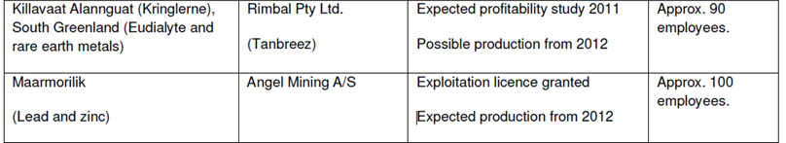
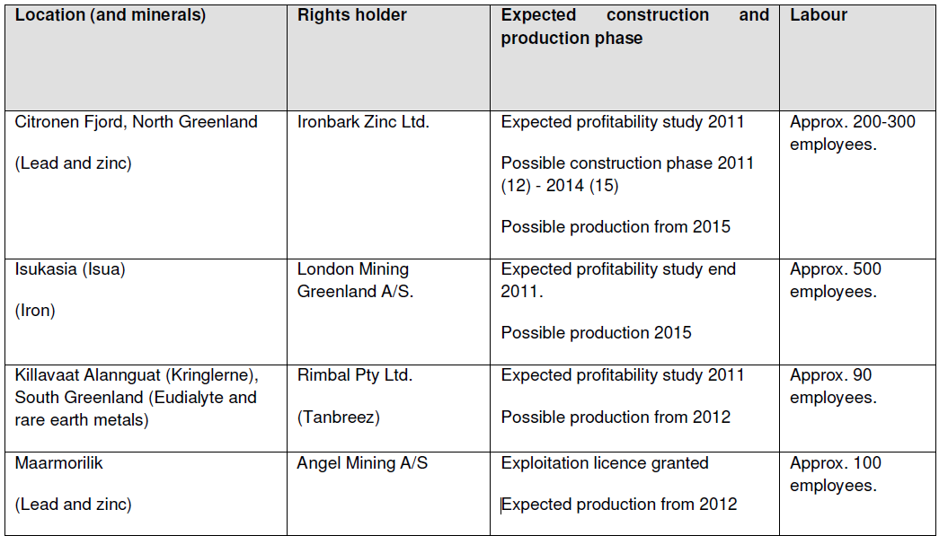
Table 8: Status of most mature exploration and exploitation projects
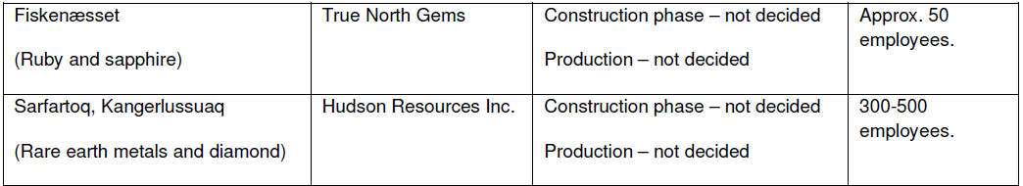
Source: Bureau of Minerals and Petroleum (February 2011).
Table 9: Government Take, depending on size of oilfield
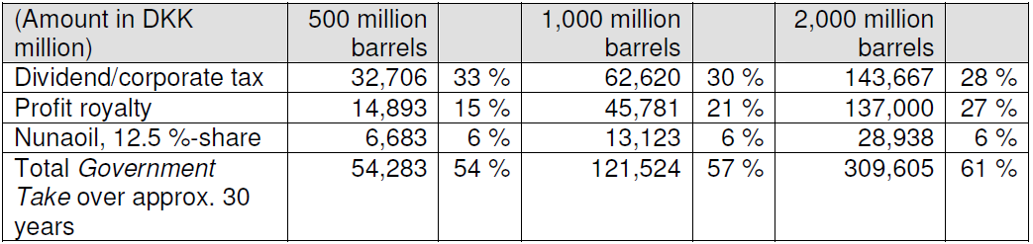
Source: Bureau of Minerals and Petroleum (February 2011).

Laws on Mineral Activities
The legal foundation and regulation for minerals and hydrocarbons is now based on the Greenland Parliament Act No. 7 from December 2009 that came into force from 1st January 2010. The Act gives a framework for the activities and the main principles for the administration of mineral resources. It also authorises the Greenland government to lay down provisions in executive orders and to decide license terms. The Act aims at ensuring that activities under the Act are securely performed with regard to safety, health and the environment. Furthermore, the resource exploitation and social sustainability are properly performed according to acknowledged best international practices under similar conditions.
The Act includes 20 parts with 98 articles. Part 1 article 2 states that the Greenland Home Rule Government has the right to control and use mineral resources in the subsoil in Greenland. It includes prospecting, exploration and exploitation of mineral resources as well as export of mineral resources. It also includes the subsoil relating to mineral activities. Furthermore, the use of energy from water, wind and the subsoil is included. The Greenland Home Rule can undertake research activities alone or in cooperation with Danish institutions as well as relevant institutions from other countries.
Part 2, article 5, states that minerals are to be understood as hydrocarbons and other minerals. The Act also outlines the framework for offshore facilities and installations as well as for accommodation business. The prospecting conditions are stated in part 4, article 15. The exploration and exploitation are stated in part 5, 6, 7, 8 and 9. An exploitation license is valid for up to 50 years. The prospecting licensing fees include an application fee (3,000 DKK), a granting fee (19,300 DKK) and a transfer fee (11,200 DKK). Exploration license fees include an application fee of 5,000 DKK and a granting fee referring to the number of years, plus an enlargement and a transfer fee. The annual licenses fee from 6 to 10 years is 36,700 DKK.
Exploration license obligations are related to the number of years, and activities per km². It is the highest fee in the fee system. Furthermore, there is an exploitation license with a granting fee of 100,000 DKK. The mentioned sizes of the fees are as of 1st January 2012. The earlier mining laws were less specific and had their start in the 1930s. The Danish law on subsoil rights from 1932 was decided by the Danish Parliament in 1935 also to become law in Greenland. All rights belonged, referring to the law, to the Danish state. It has also been the case before, but by the law it was formalised.
In 1960 the Danish government decided that a commission should come up with a proposal for a new law. One Greenlander was appointed to the commission. The intention was not to change ownership, but to try to give incentives to Danish and foreign companies to start mining activities. It resulted in a new mining law in 1965. The law includes paragraphs that gave a minimal influence to the Greenlanders. Mining concessions should be presented to the Council of Greenlanders that existed at that time (Landsrådet) but that council had no constitutional power to require information on concessions or to have their comments taken into account. Most important was that the administrative financial body in Greenland (Landskassen) should receive a part of the income from the mining activities, but the formulation was weak.
First in connection to the Home Rule negotiations in the 1970s the question of ownership of the subsoil rights became important and a matter of conflict between Denmark and Greenland. There was a strong discussion. The main roots of the discussion were that plans on petroleum investigations on the West coast of Greenland were on the agenda (the five oil drillings mentioned earlier) together with the fact that the 1972 referendum in Greenland on EU membership had shown a majority for non-membership (70 percent of the voters).
In 1974 the Greenlandic politician Otto Steenholdt, who was known for being very friendly to the Danes, as the first Greenlander, raised the question of ownership of the subsoil rights, arguing that the Greenlanders felt that the subsoil rights were taken away from them as if they were children. Also the later first Premier from the Siumut political party, Jonathan Motzfeldt, argued intensively for Greenland to achieve the subsoil rights.
During the negotiation on Home Rule, the political parties in Greenland were established. Three parties were formed, Siumut, a political party having a Social Democratic foundation, a right-wing political party (with Otto Steenholdt), called Atassut, and a left-wing political party called Inuit Ataqatigiit (IA). IA found the question decisive for having Home Rule Act, but the Danish government was totally against it, and the then-Danish Prime Minister Anker Jørgensen stated that if Greenland should have the subsoil rights, Greenland could not be a part of the Danish Kingdom.
The negotiations were extremely difficult, but without violence. The final result was that a non-juridical formulation found in article 8 of the Home Rule Act that reads: “The resident population in Greenland has fundamental rights in respect of Greenland’s natural resources”. In reality it meant that the question was postponed to later. [The above text is based on Michelsen (1987), Lyck (1996), Archer and Joenniemi (2003) and the Home Rule Act.]

Strategy for Mining Activities
The Bureau of Minerals and Petroleum of Greenland publishes the strategies for mineral activities. It was done in 2004 and again in 2009. The objectives are as follows:
- Greenland shall be recognised as an attractive exploration area
- A reasonable proportion of profits generated by extraction should be ensured for the society
- License conditions must be reasonable for both small and large companies, adapted to fluctuating economic trends, and simple and easy to administer for companies and authorities
- It must be possible to implement the strategy within the framework of the new mining law from December 2009 that came into force by 1st January 2010
A fundamental idea behind the strategy is that mining shall become an important industry in the Greenland economy. Furthermore, the activities shall be carried out properly in relation to health and environment as well as to the Greenland culture. It includes licences for prospecting, for exploration, for exploitation, for field work and for reporting. It also includes marketing. It is characteristic that the laws and conditions from other countries are studied and compared to for competition reasons. [Information based Mineral Strategy made by the Government of Greenland.]

Status on Mineral Resources in Greenland
The content of the mining activities is shown in table 10.

Table 10: Status of mineral licences as of 31/12 2010
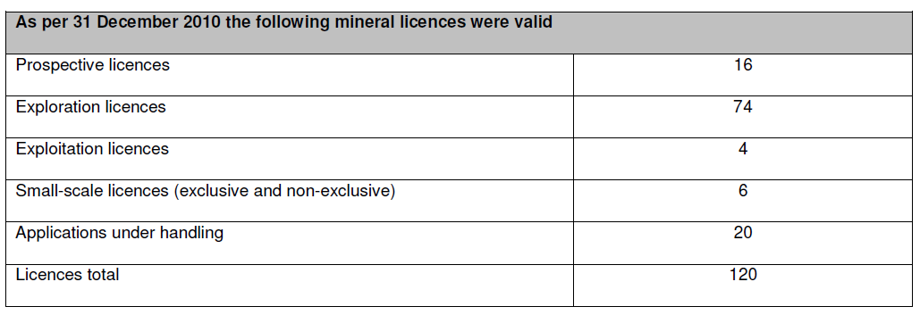
Source: Bureau of Minerals and Petroleum (February 2011).

The exploration activities are found to be at a satisfying level. The problem is that too few exploitation activities take place. It is mainly due to many corporations have a game oriented strategy having licences to strengthen their strategic positions in a longer perspective and not being eager to start production. It can also be a sort of waiting position on new inventions and technologies to be found.
However, it is important to notice that the mining activities give an important and rather high income to the Greenland society.

Perspectives for Ownership and Management of Natural Resources in the Sahara Region

Some main lessons learned to consider are the following, although it must be remembered that it is not possible just transfer the experiences. It seems important:
- That there is a solid economic grant from the central government involved in the process;
- To have a gradual approach;
- To have established forums for regular meetings and discussions;
- To include the international community through promoting sustainability;
- To include the United Nations framework for indigenous peoples rights where applicable. In the case of the Sahara, the local populations are consulted and involved through their representatives to the Local Councils, the Moroccan Parliament and the Royal Advisory Council for the Saharan Affairs;
- To include education of the autonomous population on its rights;
- To recognize that it is a process that takes time;
- To investigate how regional arrangements and regionalisation can be a part of the process.

Studying the Moroccan proposal many of the mentioned lessons learned are considered and included in a draft form, but they could probably be further elaborated in order to have more progress in the process.

Conclusion

It can be concluded that:
- Despite the differences between the political, social and historical contexts of the two regions, Greenland and the Sahara region have been through an enormous development since the end of World War II (for Greenland) and since 1976 (for the Sahara region).
- A planned development giving high priority to the economy, culture and education has shown that such a development can take place without war and the use of weapons.
- A well-negotiated autonomy is the adequate response and frame of a solution that could enhance peace, unity and development.
- Needed is expertise in negotiations and also in tolerance and an acceptance of gradual approaches. In this context, Greenland’s experience could inspire a good negotiation process that would bring peace, democracy and development to the Maghreb region, through a mutually acceptable political and negotiated solution based on autonomy.
- Whatever the future of Greenland is, it will be decided by the Greenlanders. However, the important factors are found to be a prosperous economic and cultural development that maximises the outcome of the resources in a sustainable way and in a peaceful process.

Bibliography
- Act no 577 of 29 November 1978, The Greenland Home Rule Act, Statsministeriet
- Act no 7 of December 7, 2009, On Mineral Resources and Mineral Resource Activities (The Mineral Resource Act), Greenland Parliament
- Archer C. and Joenniemi, P. (2003)
- BBC Business News, 2012, “US, EU and Japan Challenge China on Rare Earths at WTO”, 13 March 2012
- Bureau of Minerals and Petroleum (January 2011): Adjustment of Fees and Exploration Commitments for Mineral Licenses as of January 1, 2011,
- Bureau of Minerals and Petroleum (January 2012): Adjustment of Fees and Exploration Commitments for Mineral Licenses as of January 1, 2012,
- Bureau of Minerals and Petroleum (February 2011): Mineral resource activities 2010, Greenland Self-Government
- Christiansen, F.G. (1998): Forskningsdrevet olieefterforskning i Vestgrønland i 1990erne”, De nationale Geologiske Undersøgelser for Danmark og Grønland, fra Årsberetning 1998, GEUS
- Christensen, A.M. and Jensen, C.M. (2012) ”Kvartalsoversigt. 1 kvartal 2012, del 1” Nationalbanken Danmark, København.
- CNN (2010): The Race for Rare Earths, CNN Money, by Katherine Ryder, 5 October 2010
- Convention:C169 (1989): Convention Concerning Indigenous and Tribal Peoples in Independent Countries, The General Conference of the International Labour Organization, Geneva, 76th Session of the Conference, Indigenous and Tribal Peoples
- Danish Central Bank, 2012: http://www.nationalbanken.dk/
- Gad, F. (1984) “Grønland (Politikens Danmarkshistorie)”, København
- Geraae, L. (2011), Indhandling og fangst af fisk og skaldyr 1. halvår, 2011 Pressemeddelelse
- Gorbachev, Mikhail. Speech, 1987 http://www.barentsinfo.fi/docs/Gorbachev_speech.pdf
- Greenland Statistics Politics, 2012: http://www.stat.gl/dialog/main.asp?lang=en&theme=Politics%20and%20Administration&link=PA
- Grønland Statistisk Fiskeri og fangst 2011:2, 30 November 2011
- Government of Greenland Naallakkersuisut (2009), Mineral Strategy 2009 – Update of objectives and plans for mineral exploration activities in Greenland
- Danmarks ældste forretninger 1100-1911, Kraks Forlag 1950
- Dysprosium, 2012: Dysprosium egenskaber m.m. 2012
- European Commission (2007), Fiskeripartnerskabsaftaler, http://ec.europa.eu/fisheries/cfp/international/agreements/greenland/index_da.htm
- Ingeniøren: (13 April 2012):Thorning må en tur til grønland og skaffe dysprosium
- ILO (1989): C169 Indigenous and Tribal Peoples Convention, Indigenous and Tribal Convention and Recommendation, 1957
- Lidegaard, M (1991) “Grønlands Historie”, København.
- Lov nr. 473 af 12/06/2009, Selvstyreloven, Offentliggørelsesdato: 13-06-2009, Statsministeriet
- Lyck, L. (1989) “Arktiske økonomiers internationalisering, strategivalg og udviklingsmuligheder”, Svalbard seminar arranged by the University of Tronheim and SINTEF (the association of Norwegian Engineers)
- Lyck, L. (1990): Circumpolar Development, Western Regional Science Association
- Lyck, L. (1990): Prospects for Sustainable Development in the Arctic in the Ligth of International Political and Economic Changes, The third Northern Regions Conference: and Opportunity for our Future, Session III Arctic Security and Political Cooperation Part C: The Politics and Cooperation in Arctic September
- Lyck, L. ed. (1996) : Constitutional and Economic Space of the Small Nordic Jurisdictions, NiorRefo, Nordic Regional Forskning
- Lyck, L. (2012) “Development of the Greenland Home Rule Model and its Relevance to an AutonomySStatute for the Sahara Region” Paper presented to the International Research Seminar on “Governance in Autonomy Statuses: Institutions and Mechanisms”, held in Geneva on 22 March 2012.
- Koch, C (1966): Den Nye Grønlandske Minelov, Tidsskriftet Grønland, 1966, 5, Artikel 03
- Michelsen, J.(1987): Grønlandsk minelovgivning før hjemmestyret”, Politica bind 19, København
- Nanoq (2010): Grønlands Internationale Fiskeriaftaler,
- Nanoq, 2012: http://dk.nanoq.gl/Emner/Erhverv/Erhvervsomraader/Fiskeri/Fiskeristyrelsen/Internationale_relationer_og_aftaler/Internationale_fiskeriaftaler.aspx
- New York Times (2010): ”China Said to Widen its Embargo of Minerals,”19 October, 2010
- OECD, Country Note on National Fisheries Management System – Greenland
- Pedersen K. (2012): Kina skal presses til at frigive sjældne it-råstoffer, af Karim Pedersen, 14 March 2012
- Ramskov, J, (2012): Leder: Thorning må en tur til Grønland og skaffe dysprosium
- Topp. N. (1990): Kryolitindustriens Historie 1847-1900, I-II. (Kryolitselskabet Øresund A/S, ).
- United Nations, Security Council, 13 April 2007, S/2007/206
- United Nations (2008), United Nations Declaration of the Rights of Indigenous People, 07-588681- March 20008 -4,000

Annex 1:

Fields of responsibility assumed by the Greenland Home Government under Section 4 of the Home Rule Act

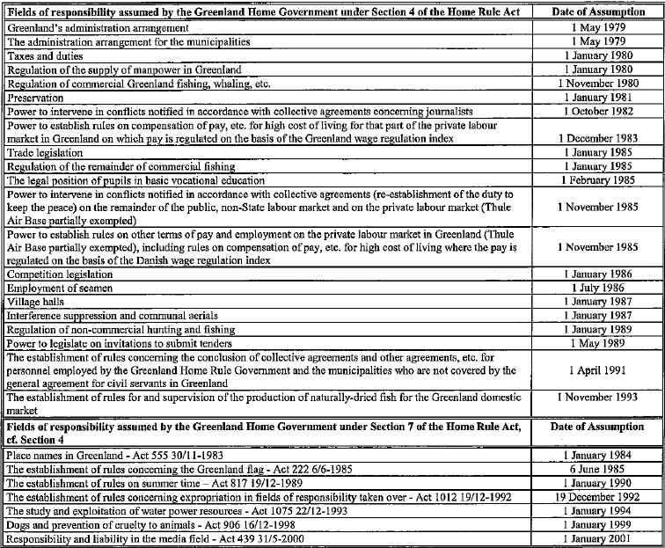

Fields of responsibility assumed by the Greenland Home Government under Section 5 of the Home Rule Act
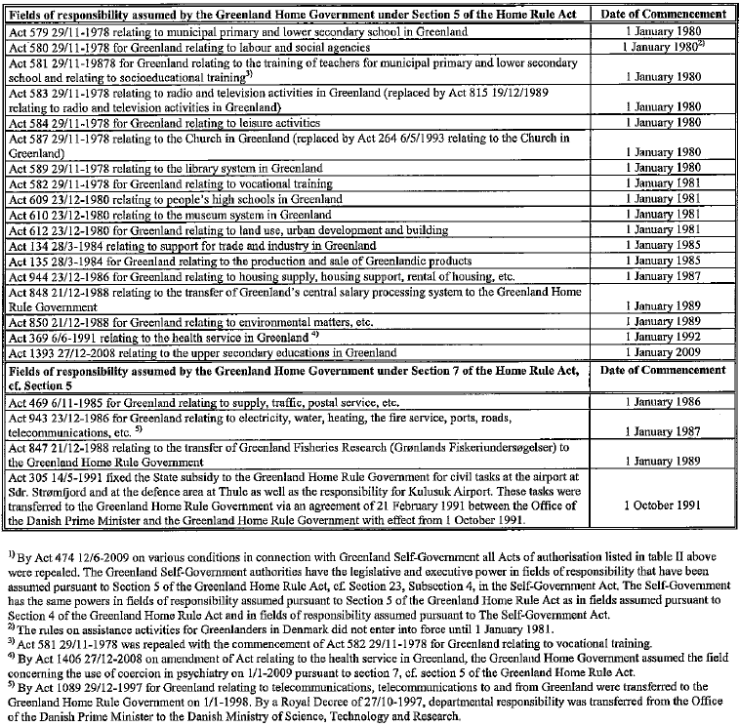
Fields of responsibility assumed by the Greenland Self-Government under Section 2 of the Self-Government, cf. Section 3

Annex 2:

Greenland

Fisheries partnership agreement (FPA)
The fisheries partnership agreement concluded between the EU and Greenland covers the period 1.1.2007 – 31.12.2012 with a financial contribution of 15 847 244 € including a financial reserve of 1 540 000 € for additional capelin and/or cod quotas and 3 261 449 € for defining and implementing a sectoral fisheries policy in Greenland.
This fisheries agreement allows EU vessels mainly from Germany, Denmark, UK, Spain, Portugal to fish in Greenland waters.

Main features of the FPA
Duration of the agreement: | 6 years renewable (1.1.2007 – 31.12.2012)
Duration of the protocol: | 6 years (1.1.2007 – 31.12.2012)
Initialisation: | 2.6.2006
Nature of the FPA: | Mixed agreement but allocation of quotas is submitted to the TAC and quota regulation
Financial contribution: | 15,847,244 € including a financial reserve of 1,540,000 € for additional capelin and/or cod quotas and 3,261,449 € for defining and implementing a sectoral fisheries policy in Greenland

License fees
Species | €/per ton
Cod | 90
Redfish | 53
Greenland halibut | 129
Shrimp | 80
Atlantic halibut | 217
Capelin | 5
Snowcrab | 120

Fishing possibilities as set out in protocol (tonnes)
 | 2007 | 2008-2012
Cod* | 1,000* | 3,500*
Redfish | 10,838** | 8,000
Greenland halibut | 10,000 | 10,000
Shrimp | 11,000 | 11,000
Atlantic halibut | 1,400 | 1,400
Capelin | 55,000* | 55,000*
Snowcrab | 500 | 500
By-catches | 2,600 | 2,300
Total | 92,338 | 91,700
*These quotas may be increased if scientific advice allows. An amount of 1,540,000 €/year is set aside equalling either 4,888 t of cod or 88,000 t of capelin or any combination thereof.
**Reduced to 9,750 t for 2007 following management measure adopted in NEAFC

History
The first fisheries agreement concluded between the EU and Greenland which dates back to 1985 was concluded for an initial period of ten years and thereafter extended for additional six-year periods until it was replaced by the fisheries partnership agreements. The first fisheries agreement was implemented by successive protocols.

Legal history of the fisheries agreements
The legal history of the fisheries agreements can be accessed through EUR-Lex. To search please type "GREENLAND" in the field "Search for", and type "FISH*" in the field "with". Then click the button "search".

Current legal framework
Fisheries Partnership Agreement and protocol: Adopted by Council Regulation (EC) 753/2007 of 28.6.2007 (OJ EU L172 of 30.6.2007)

Annex 3: Act on Greenland Home Rule Act of 2009 (Included the Non-transferred Areas)

Act no. 473 of 12 June 2009
Act on Greenland Self-Government
WE, MARGRETHE THE SECOND, by God's Grace Queen of Denmark, hereby announce that:
The Danish Parliament has passed the following Act, which We have ratified by giving Our assent:
Recognising that the people of Greenland is a people pursuant to international law with the right of self-determination,
the Act is based on a wish to foster equality and mutual respect in the partnership between Denmark and Greenland.
Accordingly, the Act is based on an agreement between Naalakkersuisut [Greenland Government] and the Danish Government as equal partners.
CHAPTER 1 - THE SELF-GOVERNMENT AUTHORITIES AND THE COURTS
1. The Greenland Self-Government authorities shall exercise legislative and executive power in the fields of responsibility taken over. Courts of law that are established by the Self-Government authorities shall exercise judicial power in Greenland in all fields of responsibility. Accordingly, the legislative power shall lie with Inatsisartut [Greenland Parliament], the executive power with Naalakkersuisut, and the judicial power with the courts of law.
CHAPTER 2 - THE SELF-GOVERNMENT AUTHORITIES’ ASSUMPTION OF FIELDS OF RESPONSIBILITY
2. (1) The Greenland Self-Government authorities may determine that the fields of responsibility that appear from the Schedule to this Act shall be transferred to the Self-Government authorities.
(2) To the extent that several fields of responsibility are listed under the same paragraph or number in the Schedule to this Act, the fields of responsibility concerned shall be transferred to the Greenland Self-Government authorities at the same time, but see subsection (3).
(3) The Greenland Self-Government authorities may determine that part of the fields of responsibility that are listed in List I, para b and List II, Nos. 15, 25 and 27 in the Schedule to this Act shall be transferred to the Self-Government authorities.
3. (1) Fields of responsibility that appear from List I of the Schedule shall be transferred to the Greenland Self-Government authorities at points of time fixed by the Self-Government authorities.
(2) Fields of responsibility that appear from List II of the Schedule shall be transferred to the Greenland Self-Government authorities at points of time fixed by the Self-Government authorities after negotiation with the central authorities of the Realm.
4. Naalakkersuisut and the Government may agree that fields of responsibility which exclusively concern Greenland affairs, and which are not referred to in the Schedule, may be assumed by the Greenland Self-Government authorities.
CHAPTER 3 - ECONOMIC RELATIONS BETWEEN THE GREENLAND SELF-GOVERNMENT AUTHORITIES AND THE DANISH GOVERNMENT
5. (1) The Government shall grant the Greenland Self-Government authorities an annual subsidy of DKK 3,439.6 million, but see section 8 (1). The amount is indicated in 2009 price and wage levels.
(2) The subsidy shall be adjusted annually in accordance with the increase in the general price and wage index of the Finance and Appropriation Act for the year concerned.
(3) The subsidy shall be paid in advance in the form of a monthly payment of 1/12.
(4) Subject to agreement with Naalakkersuisut, the Minister for Finance may lay down rules on changed dates for disbursement.
6. (1) Fields of responsibility that are assumed by the Greenland Self-Government authorities pursuant to sections 2-4 shall be financed by the Self-Government authorities from the date of assumption.
(2) The Greenland Self-Government authorities shall assume the real assets that are directly related to a field of responsibility that is taken over.
7. (1) Revenue from mineral resource activities in Greenland shall accrue to the Greenland Self-Government authorities.
(2) The revenue referred to in subsection (1) shall include the following revenue:
1) Revenue in accordance with specific licenses for prospecting for, exploration for, or the exploitation of mineral resources. This shall not, however, include amounts paid to cover expenditure under the auspices of the Bureau of Minerals and Petroleum.
2) Revenue from any taxation in Denmark and Greenland of licence holders with respect to the part of the business that relates to mineral resources in Greenland.
3) Revenue from Greenland and Danish public authorities’ stakes in companies, etc. that operate in the mineral resource area in Greenland.
4) Revenue from withholding tax, etc. in Denmark and Greenland concerning shareholders in companies that are licence holders, or in companies that entirely own such companies directly or indirectly and can receive tax-free dividend from these.
8. (1) If revenue from mineral resource activities in Greenland accrues to the Greenland Self-Government authorities, cf. section 7, the Government’s subsidy to the Self-Government authorities shall be reduced by an amount corresponding to half the revenue which, in the year concerned, exceeds DKK 75 million.
(2) With effect from 1 January the year after the commencement of the Act, the amount of DKK 75 million referred to in subsection (1) shall be adjusted annually in accordance with the increase in the general price and wage index of the Finance and Appropriation Act for the year concerned.
(3) Calculation pursuant to subsection (1) shall take place the subsequent year with a view to payment the following year.
9. (1) With the assumption of the mineral resource area by the Greenland Self-Government authorities, the Government shall, against payment, ensure the provision of consultancy and other attendance to tasks for the purpose of the Self-Government authorities’ attendance to the mineral resource area.
(2) With effect from the Greenland Self-Government authorities’ assumption of the mineral resource area, Naalakkersuisut and the Government shall conclude an agreement on the services referred to in subsection (1).
(3) Naalakkersuisut may decide to renew the agreement referred to in subsection (2) in the form of multi-year agreements.
(4) Where agreements are concluded pursuant to subsection (2) and subsection (3), the Government shall, free of charge, provide Naalakkersuisut with research of special relevance to mineral resource exploration in Greenland.
10. If the Government’s subsidy to the Greenland Self-Government authorities is reduced to zero kroner, cf. section 8, negotiations shall be initiated between Naalakkersuisut and the Government regarding the future economic relations between the Greenland Self-Government authorities and the Government. The negotiations shall include the distribution of revenue from mineral resource activities in Greenland, resumption of the Government’s subsidy to the Greenland Self-Government authorities, and continuation of an agreement regarding the services referred to in section 9.
CHAPTER 4 - FOREIGN AFFAIRS
11. (1) Naalakkersuisut may act in international affairs as laid down in this Chapter and in agreements with the Government.
(2) The Government and Naalakkersuisut shall cooperate in international affairs as laid down in this Chapter with a view to safeguarding the interests of Greenland as well as the general interests of the Kingdom of Denmark.
(3) The powers granted to Naalakkersuisut in this Chapter shall not limit the Danish authorities’ constitutional responsibility and powers in international affairs, as foreign and security policy matters are affairs of the Realm.
12. (1) Naalakkersuisut may, on behalf of the Realm, negotiate and conclude agreements under international law with foreign states and international organisations, including administrative agreements which exclusively concern Greenland and entirely relate to fields of responsibility taken over.
(2) Agreements under international law which exclusively concern Greenland and the Faroe Islands and entirely relate to fields of responsibility taken over may, subject to decision by Naalakkersuisut as well as the Faroe Islands Landsstyre [Government of the Faroes], be negotiated and concluded jointly on behalf of the Realm by Naalakkersuisut and the Faroe Islands Landsstyre.
(3) Agreements under international law concluded pursuant to subsection (1) or subsection (2) may be terminated according to the same provisions.
(4) Agreements under international law affecting the defence and security policy as well as agreements under international law which are to apply to Denmark, or which are negotiated within an international organisation of which the Kingdom of Denmark is a member shall be negotiated and concluded according to the rules laid down in section 13.
(5) Naalakkersuisut shall inform the Government of negotiations under consideration before these are initiated and of the development of the negotiations before agreements under international law are concluded or terminated. A more detailed framework for the cooperation in accordance with this provision shall be determined after negotiation between Naalakkersuisut and the Government.
(6) Agreements under international law pursuant to subsection (1) shall be concluded on behalf of the Realm by Naalakkersuisut under the designation of:
a) The Kingdom of Denmark in respect of Greenland where the agreement appears as concluded between states.
b) Naalakkersuisut where the agreement appears as concluded between governments or between administrative authorities. In that case, reference shall be made in the preamble of the agreement to the present Act as specified pursuant to subsection (8).
(7) Agreements under international law pursuant to subsection (2) shall be concluded jointly on behalf of the Realm by Naalakkersuisut and the Faroe Islands Landsstyre under the designation of the Kingdom of Denmark in respect of the Faroe Islands and Greenland.
(8) More detailed rules for the use of designations referred to in subsections (6) and (7) as well as other similar designations may be determined in accordance with subsection (5).
13. (1) The Government shall inform Naalakkersuisut before negotiations are initiated regarding agreements under international law which are of particular importance to Greenland. Subject to request by Naalakkersuisut, an agreement may be concluded with the Minister concerned who shall lay down detailed cooperation rules within the framework of this provision, including a detailed determination of criteria for when agreements shall be deemed to be of particular importance to Greenland.
(2) In matters which exclusively concern Greenland, the Government may authorise Naalakkersuisut to conduct the negotiations, with the cooperation of the Foreign Service.
(3) Agreements where Denmark and Greenland have been jointly involved in the negotiations shall be signed by the Government, to the widest extent possible, together with Naalakkersuisut.
(4) Agreements under international law which are of particular importance to Greenland must, before they are concluded or terminated, be submitted to Naalakkersuisut for comments. If the Government deems it necessary to conclude the agreement without the consent of Naalakkersuisut, this shall, to the widest extent possible, have no effect for Greenland.
14. Where international organisations allow entities other than states and associations of states to attain membership in their own name, the Government may, subject to request by Naalakkersuisut, decide to submit or support such an application from Greenland where this is consistent with the constitutional status of Greenland.
15. As requested by Naalakkersuisut, representatives of Naalakkersuisut shall be appointed to the diplomatic missions of the Kingdom of Denmark to attend to Greenland interests within fields of responsibility that have been entirely assumed by the Self-Government authorities. The Government may determine that expenditure to this end shall be borne by Naalakkersuisut.
16. (1) Greenland Self-Government authorities shall be subject to the obligations that arise out of agreements under international law and other international rules which are at any time binding on the Realm.
(2) Measures under consideration by the Self-Government authorities which would be of substantial importance for the foreign relations of the Realm, including participation by the Realm in international cooperation, shall be negotiated with the Government before any decision is taken.
CHAPTER 5 - COOPERATION BETWEEN THE GREENLAND SELF-GOVERNMENT AUTHORITIES AND THE CENTRAL AUTHORITIES OF THE REALM REGARDING STATUTES AND ADMINISTRATIVE ORDERS
17. (1) The Government’s Bills which comprise or may be brought into force for Greenland must, before they are presented to the Folketing, be submitted to the Greenland Self-Government authorities for comments.
(2) The Government shall await the Self-Government authorities’ comments before presenting Government Bills to the Folketing which contain provisions that exclusively apply to Greenland or are of particular importance to Greenland.
(3) A time limit may be fixed for the submission of comments comprised by subsection (2).
18. (1) Draft administrative orders which comprise or may be brought into force for Greenland must, before they are issued, be submitted to the Greenland Self-Government authorities for comments.
(2) The issue of administrative orders which contain provisions that exclusively apply to Greenland or are of particular importance to Greenland shall await the Self-Government authorities’ comments.
(3) A time limit may be fixed for the submission of comments comprised by subsection (2).
CHAPTER 6 - DISPUTE RESOLUTION
19. (1) Should any question of doubt arise between the Greenland Self-Government authorities and the central authorities of the Realm concerning the Self-Government authorities’ responsibility in relation to the central authorities, the Government or Naalakkersuisut may decide to lay the question before a board consisting of two members nominated by the Danish Government, two members nominated by Naalakkersuisut, and three judges of the Supreme Court nominated by its President, one of whom shall be nominated as chairman.
(2) If the four members nominated by the Government and Naalakkersuisut reach agreement, the question shall be considered settled. If these four fail to reach agreement, the question shall be decided by the three Supreme Court judges.
(3) The board may decide to suspend the enactment or decision which has been placed before the board until such time as the board’s decision is taken.
CHAPTER 7 - LANGUAGE
20. Greenlandic shall be the official language in Greenland.
CHAPTER 8 - GREENLAND’S ACCESS TO INDEPENDENCE
21. (1) Decision regarding Greenland’s independence shall be taken by the people of Greenland.
(2) If decision is taken pursuant to subsection (1), negotiations shall commence between the Government and Naalakkersuisut with a view to the introduction of independence for Greenland.
(3) An agreement between Naalakkersuisut and the Government regarding the introduction of independence for Greenland shall be concluded with the consent of Inatsisartut and shall be endorsed by a referendum in Greenland. The agreement shall, furthermore, be concluded with the consent of the Folketing.
(4) Independence for Greenland shall imply that Greenland assumes sovereignty over the Greenland territory.
CHAPTER 9 - ENTRY INTO FORCE AND TRANSITIONAL PROVISIONS
22. The Act shall enter into force on 21 June 2009.
23. (1) Act No. 577 of 29 November 1978 on Greenland Home Rule shall be repealed, but see subsection (2).
(2) Section 8 of the Greenland Home Rule Act shall remain in force until the mineral resource area is taken over by the Greenland Self-Government authorities.
(3) The Greenland Self-Government authorities shall continue to exercise legislative and executive power in fields of responsibility that have been assumed pursuant to section 4 of the Greenland Home Rule Act.
(4) The Greenland Self-Government authorities shall exercise legislative and executive power in fields of responsibility that have been assumed pursuant to section 5 of the Greenland Home Rule Act.
24. (1) Act No. 577 of 24 June 2005 on the conclusion of agreements under international law by the Government of Greenland shall be repealed.
(2) Orders issued in pursuance of the Act shall remain in force with the amendments that arise out of this Act until they are amended or repealed by the proper authority.
25. Section 22 of the Act on Mineral Resources in Greenland, cf. Consolidation Act No. 368 of 18 June 1998 shall be repealed.
26. Act on the establishment of a company to attend to hydrocarbon activities in Greenland, etc., cf. Consolidation Act No. 87 of 9 February 1999 shall be repealed.
27. Act No. 502 of 6 June 2007 on subsidy to the Greenland Home Rule in 2008 and 2009 shall be repealed.
28. Provisions that apply to Greenland shall remain in force with the amendments that arise out of this Act until they are amended or repealed by the proper authority.
29. (1) Matters which at the time of transfer of a field of jurisdiction to the Greenland Self-Government authorities are under consideration by a Danish authority shall be finalised by the Greenland authority concerned, but see subsection (2).
(2) The Danish authority concerned may in special cases and subject to agreement with the Greenland authority concerned decide that certain specific matters shall be finalised by the Danish authorities.
Given at Amalienborg on 12 June 2009
Under Our Royal Hand and Seal
MARGRETHE R.
/ Lars Løkke Rasmussen
SCHEDULE
List I
a) Industrial injury compensation
b) The remaining areas under the health care area
c) The road traffic area
d) The law of property and obligations
e) The commercial diving area
List II
1) Prison and probation service
2) Passports
3) Police and prosecution service as well as related parts of the administration of criminal justice
4) Administration of justice, including the establishment of courts of law
5) Criminal law
6) The aliens area and border controls
7) Law of capacity
8) Family law
9) Succession law
10) Law practice
11) The weapons area
12) Radio-based maritime emergency and security services
13) The radio communications area
14) The company, accounting and auditing area
15) The food and veterinary area
16) Aviation
17) Intellectual property
18) Copyright
19) Shipwreck, wreckage and degradation of depth
20) Security at sea
21) Ship registration and maritime matters
22) Charting
23) The buoyage, lighthouse and pilotage area
24) Marine environment
25) Financial regulation and supervision
26) The mineral resource area
27) The working environment
28) Meteorology

Centre Director and Associate Professor, Copenhagen Business School.
Letter dated 11 April 2007, addressed to the President of the UN Security Council by the Permanent Representative of Morocco to the United Nations.
The UN General Assembly took note of this Agreement in its resolution 3458 (XXX) E3. 10/12/1975.
The Advisory Council is composed of members previously elected to the former council by their tribes, sheikhs of tribes, members of associations belonging to civil society and youth organizations in the southern provinces, representatives of Moroccan natives of the southern provinces living abroad, representatives of the Tindouf camps populations, representatives of socio-economic operators and bodies and eminent personalities.
International Fertilizer Development Center (IFDC), “World Phosphate Rock Reserves and Resources,” Technical Bulletins, No. 75, 2010 (available at: http://www.ifdc.org/getdoc/56358fb1-fc9b-49ba-92fe-187dc08e9586/T-75_World_Phosphate_Rock_Reserves_and_Resources).
Founding speech delivered by King Mohammed VI in Laâyoune on 25 March 2006 (http://www.corcas.com).

